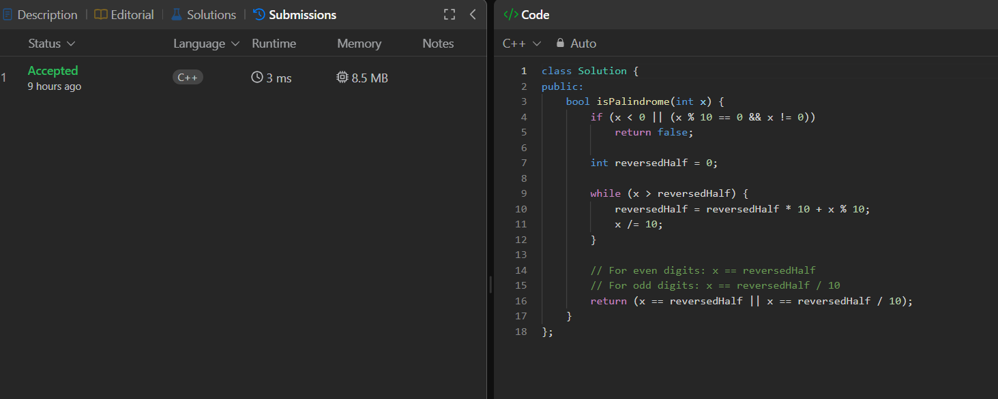
class Solution {
public:
bool isPalindrome(int x) {
if (x < 0 || (x % 10 == 0 && x != 0))
return false;

int reversedHalf = 0;

while (x > reversedHalf) {
reversedHalf = reversedHalf * 10 + x % 10;
x /= 10;
}

// For even digits: x == reversedHalf
// For odd digits: x == reversedHalf / 10
return (x == reversedHalf || x == reversedHalf / 10);
}
};

